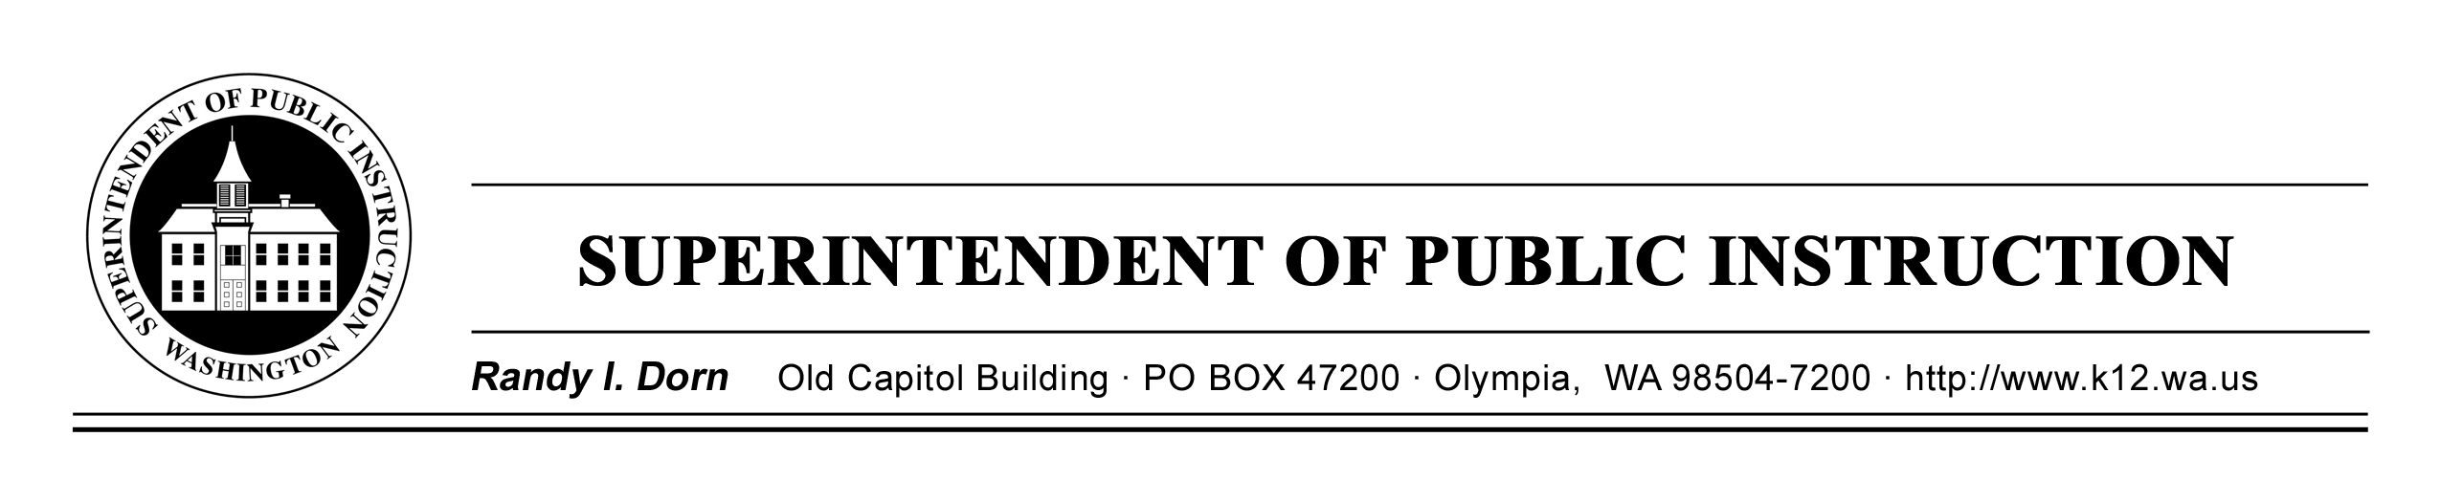

September 9, 2014 (x) Action Required
Due Date: November 14, 2014
( ) Informational

MEMORANDUM NO. 047-14M TITLE I/LAP & CONSOLIDATED PROGRAM REVIEW

TO: Educational Service District Superintendents
Educational Service District Assistant Superintendents
School District Superintendents
Elementary and Secondary School Principals
School District Title I, Part A Directors
Federal Program Directors

FROM: Randy I. Dorn, State Superintendent of Public Instruction

RE: 2014 Title I, Part A Distinguished Schools Award Program

CONTACT: Larry Fazzari, Program Supervisor, Title I, Part A/LAP
(360) 725-6189; TTY: (360) 664-3631
Email: larry.fazzari@k12.wa.us

The Office of Superintendent of Public Instruction (OSPI) is currently accepting applications for the 2014 Washington State Title I, Part A Distinguished Schools Award.

Distinguished Schools Award Recognition
Four schools will be recipients of this award. Two schools will be selected in the national category and two schools will be selected in the state category. Each submission must determine category and content area which the school is emphasizing: exceptional student performance for two or more consecutive years or significant progress in closing the achievement gap between student groups.

National Recognition
Two schools overall will be selected for the national recognition category, one school in each of the categories below:

- One school selected will represent the Title I, Part A schools which have shown exceptional student performance for two or more consecutive years.
- One school selected will represent the Title I, Part A schools which have significantly closed the achievement gap between student groups.

MEMORANDUM NO. 047-14M TI/LAP/CPR
Page 2
September 9, 2014

The two schools receiving the 2014 National Distinguished Schools Award will receive recognition and be honored at the 2015 National Title I Conference in Salt Lake City, Utah, February 2–5, 2014. These schools will also receive state-level recognition and $10,000.

State Recognition
Two schools will be selected for the State Distinguished Schools Award. The two schools receiving the 2014 State Distinguished Schools Award will be invited to attend the 2015 National Title I Conference in Salt Lake City, Utah, and receive state-level recognition and $5,000.

Eligibility
Schools which meet either of the following criteria are eligible to apply for this award:

- Title I, Part A schools which have exceptional student performance and successfully exceeded their Adequate Yearly Progress (AYP) targets in reading and mathematics for the school years ending in 2011 and 2014. (AYP must be made in all cells for eligibility, or have an OSPI approved School Improvement Plan for schools with an “n” size of less than 30.)

- Title I, Part A schools which have significantly closed the achievement gap between student groups in reading and mathematics for the school years ending in 2011 and 2014. (AYP must be made in all cells for eligibility, or have an OSPI approved School Improvement Plan for schools with an “n” size of less than 30.)

Applying schools must have a poverty rate of 35 percent or higher for the 2014–15 school year. Schools that have received the National Title I, Part A Distinguished Schools Award must wait two years before applying again. However, schools that have received the State Title I, Part A Distinguished Schools Award within the two previous years are eligible to apply for the National Title I, Part A Distinguished School Award only.

Selection Considerations
The following criteria will be considered when evaluating applications:
- Teaching and learning based on the approved state standards.
- Use of research-based instructional strategies.
- Opportunities provided for all students to achieve.
- Coordination of Title I, Part A program with other programs.
- Implementation of sustained research-based professional development.
- Established partnerships with parents, families, and the community.
MEMORANDUM NO. 047-14M TI/LAP/CPR
Page 3
September 9, 2014

Application
Attachment A to this memorandum contains the 2014 Title I, Part A Distinguished Schools Award Program Application (Form 1586) which must be completed for each school being nominated.

In addition, as part of the selection process, those schools nominated for this award are subject to a site visit by the Title I, Part A Distinguished Schools Award Selection Committee.

Award notification will be made after the 2014 AYP results are available.

Please send completed applications by November 14, 2014, to:

Larry Fazzari, Program Supervisor
Title I, Part A/LAP
Office of Superintendent of Public Instruction
PO Box 47200
Olympia, WA 98504-7200

If you have any questions, please contact Larry Fazzari at (360) 725-6189 or email larry.fazzari@k12.wa.us. The agency TTY number is (360) 664-3631. This information is also available on the OSPI website at: http://www.k12.wa.us/BulletinsMemos/bulletins2014.aspx.

K–12 EDUCATION

Gil Mendoza, Ed.D.
Deputy Superintendent

SPECIAL PROGRAMS AND FEDERAL ACCOUNTABILITY

Gayle Pauley, Director
Title I/LAP & Consolidated Program Review

RD:gp:jc

Attachment A: 2014 Title I, Part A Distinguished Schools Award Program Application

OSPI provides equal access to all programs and services without discrimination based on sex, race, creed, religion, color, national origin, age, honorably discharged veteran or military status, sexual orientation including gender expression or identity, the presence of any sensory, mental, or physical disability, or the use of a trained dog guide or service animal by a person with a disability. Questions and complaints of alleged discrimination should be directed to the Equity and Civil Rights Director at (360) 725-6162 or P.O. Box 47200 Olympia, WA 98504-7200.

